**PROBLEM 1**

max Z = 2x1 + 20x2 - 10x3

2x1 + 20x2 + 4x3 <= 15

6x1 + 20x2 + 4x3 = 20

x1,x2,x3>=0 ve tamsayı olduğuna göre optimal tablosu verilmiş olan problemi kesme düzlemi algoritmasıyla çözünüz.

|  |  |  |  |  |  |  |
| --- | --- | --- | --- | --- | --- | --- |
| Z | X1 | X2 | X3 | S1 | A1 |  |
|  | 0 | 0 | 14 | 1 | M | 15 |
| X2 | 0 | 1 | 0.2 | 0.075 | -0.025 | 0.625 |
| X1 | 1 | 0 | 0 | -0.25 | 0.25 | 1.25 |

0.625=X2+0.2X3+0.075S1

-0.625=S4-0.2X3-0.075S1 (CUT 1)

|  |  |  |  |  |  |  |
| --- | --- | --- | --- | --- | --- | --- |
| Z | X1 | X2 | X3 | S1 | **S4** |  |
|  | 0 | 0 | 14 | 1 | **0** | 15 |
| X2 | 0 | 1 | 0.2 | 0.075 | **0** | 0.625 |
| X1 | 1 | 0 | 0 | -0.25 | **0** | 1.25 |
| **S4** | **0** | **0** | **-0.2** | **-0.075** | **1** | **-0.625** |

|  |  |  |  |  |  |  |
| --- | --- | --- | --- | --- | --- | --- |
| Z | X1 | X2 | X3 | S1 | **S4** |  |
|  | 0 | 0 | 11.3 | 0 | **13.3** | 6.67 |
| X2 | 0 | 1 | 0 | 0 | **-3.33** | 0 |
| X1 | 1 | 0 | 0.67 | 1 | **-13.3** | 3.3 |
| **S1** | **0** | **0** | **2.67** | **0** | **13.3** | **8.3** |

-0.33=S5-0.67X3-0.67S3 (CUT 2)

|  |  |  |  |  |  |  |  |
| --- | --- | --- | --- | --- | --- | --- | --- |
| Z | X1 | X2 | X3 | S1 | S3 | S4 |  |
|  | 0 | 0 | 0 | 0 | 2 | 17 | 1 |
| X2 | 0 | 1 | 0 | 0 | 1 | 0 | 0 |
| X1 | 1 | 0 | 0 | 0 | -4 | 1 | 3 |
| S1 | 0 | 0 | 0 | 1 | -16 | 4 | 7 |
| X3 | 0 | 0 | 1 | 0 | 1 | -1.5 | 0.5 |

-0.5=S5-0.5S4(CUT 3)

|  |  |  |  |  |  |  |  |  |
| --- | --- | --- | --- | --- | --- | --- | --- | --- |
| Z | X1 | X2 | X3 | S1 | S3 | S4 | S5 | -16 |
|  | 0 | 0 | 0 | 0 | 2 | 0 | 34 | 0 |
| X2 | 0 | 1 | 0 | 0 | -4 | 0 | 0 | 2 |
| X1 | 1 | 0 | 0 | 0 | -16 | 0 | 2 | 3 |
| S1 | 0 | 0 | 0 | 1 | 1 | 0 | 8 | 2 |
| X3 | 0 | 0 | 1 | 0 | 0 | 1 | -3 | 1 |

X1=2,X2=0,X3=2 MAX Z=-16

**Problem 1 Lingo Çözümü**

max = 2*x1 + 20*x2 - 10*x3;

2*x1 + 20*x2 + 4*x3 <= 15;

6*x1 + 20*x2 + 4*x3 = 20;

@GIN(X1);

@GIN(X2);

@GIN(X3);

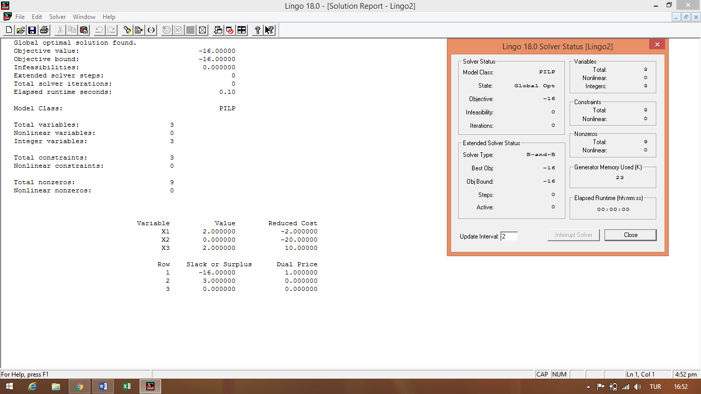END

**PROBLEM 2**

Enb z=8x1+5x2

9x1+5x2=<45

x1+x2=<6

X1,X2>=0 ve tamsayı optimal çözüm tablosu verilmiş olan problemi kesme düzlemi yöntemiyle çözünüz.

|  |  |  |  |  |  |
| --- | --- | --- | --- | --- | --- |
|  | ***x*1** | ***x*2** | ***S*1** | ***S*2** |  |
|  | 0 | 0 | 0.75 | 1.25 | 41.25 |
| *x*1 | 1 | 0 | 0.25 | -1.25 | 3.75 |
| *x*2 | 0 | 1 | -0.25 | 2.25 | 2.25 |

-0.75=s3-0.25s1-0.75s2

|  |  |  |  |  |  |  |
| --- | --- | --- | --- | --- | --- | --- |
| Iteration-1 |  |  |  |  |  |  |
| ***B*** | ***x*1** | ***x*2** | ***S*1** | ***S*2** | ***S3*** | ***Z*=41.25** |
| ***Z*** | 0 | 0 | 0.75 | 1.25 | 0 |  |
| *x*1 | 1 | 0 | 0.25 | -1.25 | 0 | 3.75 |
| *x*2 | 0 | 1 | -0.25 | 2.25 | 0 | 2.25 |
| ***S3*** | 0 | 0 | -0.25 | **(-0.75)** | 1 | -0.75 |
|  | --- | --- | -3 | -1.6667↑ | --- |  |

|  |  |  |  |  |  |  |
| --- | --- | --- | --- | --- | --- | --- |
| Iteration-2 |  |  |  |  |  |  |
|  | ***x*1** | ***x*2** | ***S*1** | ***S*2** | ***S3*** |  |
| ***Z*** | **8** | **5** | **0.3333** | **0** | **1.6667** | ***40*** |
| *x*1 | 1 | 0 | 0.6667 | 0 | -1.6667 | 8 |
| *x*2 | 0 | 1 | -1 | 0 | 3 | 5 |
| *S*2 | 0 | 0 | 0.3333 | 1 | -1.3333 | 0 |

X1=5 x2=0 Max z=40

**Problem 2 Lingo Çözümü**

max=8*x1+5*x2 ;

9*x1+5*x2<=45;

x1+x2<=6;

@gin(x1);

@gin(x2);

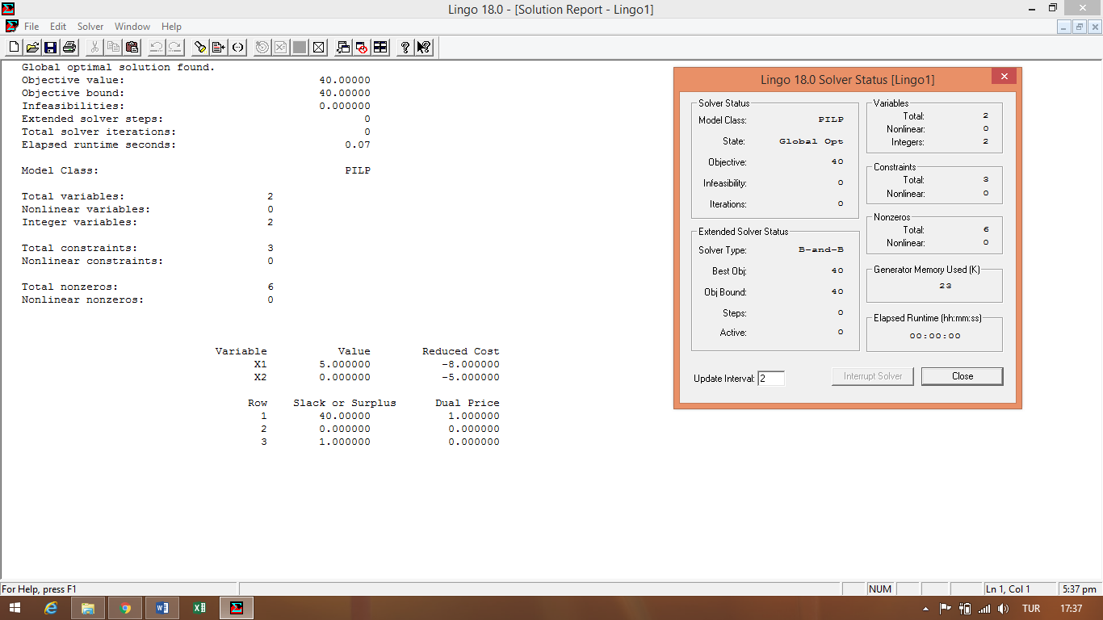end

**PROBLEM 3**

MAX z = 2 x1+ x2

5 x1 + 2 x2 <= 8

x1+ x2<= 3

x1, x2 . 0; x1 tamsayı optimal tablosu verilmiş olan problemi kesme düzlemi algoritmasıyla çözünüz.

|  |  |  |  |  |  |
| --- | --- | --- | --- | --- | --- |
|  | ***x*1** | ***x*2** | ***S*1** | ***S*2** |  |
| ***Z*** | **2** | **1** | **0.3333** | **0.3333** | **3.6667** |
| *x*1 | 1 | 0 | 0.3333 | -0.6667 | 0.6667 |
| *x*2 | 0 | 1 | -0.3333 | 1.6667 | 2.3333 |

0.6667=x1+0.3333s1-0.6667s2

0.6667=x1+0.3333s1+(-1+0.3333)

-0.6667=s3-0.33333s1-0.33333s2 (cut 1)

|  |  |  |  |  |  |  |
| --- | --- | --- | --- | --- | --- | --- |
|  | ***x*1** | ***x*2** | ***S*1** | ***S*2** | ***S3*** |  |
| ***z*** | 0 | 0 | 0 | 0 | 1 | **3** |
| *x*1 | 1 | 0 | 0 | -1 | 1 | 2 |
| *x*2 | 0 | 1 | 0 | 2 | -1 | 1 |
| *S*1 | 0 | 0 | 1 | 1 | -3 | 0 |

X1=0,x2=3 max z=3

**PROBLEM 3 LİNGO ÇÖZÜMÜ**

MAX = 2 *x1+ x2;

5 *x1 + 2 *x2 <= 8;

x1+ x2<= 3 ;

@gin(x1);

@gin(x2);

end

